**Gamification of financial system**

Chiu Cheng Wai, Winston (212668S)

Toon Chuan Zhou Jerryl (212599S)

Koh Win (210229X)

Luke Angus Tan Kang (210391S)

**Individual analysis**

Chiu Cheng Wai, Winston (Shopee)

**Scope of application:** shopee is an online shopping platform that allows people to buy items and get rewards based on money spent, there are many deals and events to allow people to save on purchases

**Gamified aspects:** individuals can buy items and gather virtual currency, which can be used to exchange for vouchers, cashbacks, and other items. The exchange rate is 100 coins for $1, which can also be used to “play minigames and interact with pets”. However, these minigames can also be used to earn coins, leading to a loop of using the coins

This leads to a higher user retention rate as individuals wish to earn coins, thus reducing real money being spent, and play the minigames. Therefore, when the virtual pet is introduced, individuals feel more inclined to play with the pet, as there are more methods of earning virtual coins.

Lastly, there is a tier system on the member’s account. Much like a bank account’s tier, the more money you spend, the higher your tier, and thus more rewards(insert rewards here), this is a positive reinforcement from the app as it encourages you to reach for higher tiers, or at least maintain it to receive rewards

**What techniques:** reward system(extrinsic), positive reinforcement(intrinsic), virtual currency(extrinsic)

**Research materials and justifications:**

Use of rewards via a virtual currency allows users to place an importance on the newly introduced currency, as such feel gratification whenever they earn it or spend it. However, since users tend to value real-world currency more, they’ll use the virtual currency to “supplement” spendage, thus saving money. In the Singaporean mindset, we place huge importance on such a feature and strive to get more benefits and deals. Thus, when introducing a member tier system, users will be encouraged to spend more money in the short term, to gain a higher tier, thus appearing to save more money in the long term. Needless to say, there is a need to maintain the tier, thus users arent really saving much money at the end of the day, spending more than they need to, just to maintain the benefits. Alongside the point system is a virtual marketplace used to exchange for vouchers, which mean that E-vouchers can also be used outside of the app and more commonly in malls. This further extends the “importance” of shopee coins, thus making it a successful implementation of gamification.

Toon Chuan Zhou Jerryl (Steam)

**Scope of application:** One of the most popular platforms which allows users to purchase/get and then play games.

**Gamified aspects:**

* When the user purchases games, steam gives them points in which they can use to customize their own steam profile. These points can also be used to buy stickers to send to other people in messages.
* Steam also has a card system in which users can earn through playing the game. These cards can then be used to level up their steam account or sold

**What techniques:**

* Level System (Extrinsic)
* Points System (Intrinsic)

**Research materials and justifications(individual):**

<https://moneyinc.com/the-five-most-expensive-steam-trading-cards/>

<https://www.pcgamesn.com/steam/points>

Koh Win (Duolingo)

**Scope of application**: Helping users learn a new language by making it fun and enjoyable. Users can practice speaking, reading and writing over 35 different languages.

**Gamified aspects:**

* Weekly Wagers: You are given a choice to double your gems or lose it all in a high stakes battle. If you choose yes, you lock a set amount of gems as the wager. You will then have to complete 1 lesson a day for the next week and then if the goal is met, your gems will be doubled. If not, they lose the wager, losing all the gems.
* Progress bar: Players can check their progress and see how far they have come with a daily progress bar and also a task progress bar which shows how much experience they have gained by learning their new language. There is also a monthly challenge of 1000 xp, which is the equivalent to around 25 lessons, where when the player completes the challenge, they will be awarded extra gems. The progress bar shows how much players have left, and it encourages them to complete it.
* Duolingo's mascot. Players can spend their hard earned gems on kitting out their birb with the fanciest outfits, then they can also share their outfits and essentially flex on their friends that they are more hardworking than them.
* Leaderboards and ranking: Players are automatically enrolled into a weekly leaderboard where they can compete with 24 other randomly selected players in the same skill group to see who can get the most points. The top 10 in the leaderboard advance to the next rank, up to diamond, and those that are in the bottom 5 demote to the previous rank. This motivates people to stay away from the demotion zone and climb the rank to impress their friends.

**What techniques:**

* Weekly Wagers(Extrinsic)
* Progress Bar (Intrinsic)
* Mascot and gems (Intrinsic)
* Leaderboards and ranking (Intrinsic)
* Leaderboard rewards (Extrinsic)

**Aesthetics**

* Challenge
* Submission

**Research materials and justifications:** I use duolingo to learn japanese every day

Luke Angus Tan Kang (Samsung Health)

**Scope of application:** Samsung Health is a health and fitness app by helping users to track and set goals

**Gamified aspects:**

* “Together”: In the “Together” tab in the app, There is a leaderboard for the user to compete among their friends and the world. Users can also level up by completing challenges.
* Badges: By achieving certain milestones, users can attain badges and show off in the user’s profile. The number of times the badge has been attained is also tracked and shown. This gives the user incentive to use the app and exercise.
* Profile Customisation: Users can personalize their profile by inserting a profile picture of their choice, changing their nickname, and selecting how much they exercise. This allows them to express themselves freely and when they show up on places like the “Together” leaderboards, they can feel accomplished.
* Progress bars: To motivate users in working out more, progress bars will help in doing so as it gives the users something to work towards and give the user the satisfaction of seeing a complete bar. Some of the progress bars form unique shapes once they are filled, like the Daily Activity progress bar forming a shape of a heart. This gives the users another incentive to finish the shape of the heart once they started it.

**What techniques:**

* Leaderboard(Intrinsic)
* Level Up(Intrinsic)
* Profile Customisation(Intrinsic)
* Progress Bars(Extrinsic)
* Badges(Extrinsic)

**Research materials and justifications:**

[**https://www.samsung.com/sg/apps/samsung-health/**](https://www.samsung.com/sg/apps/samsung-health/)

[**https://www.androidauthority.com/samsung-health-3037491/**](https://www.androidauthority.com/samsung-health-3037491/)

**Our idea**

**Overview:**

An Investing App, where users can learn more about investing money and invest their own money in various stocks.

Users will be given various tasks to accomplish in order to gain points which they can in turn use to claim gift cards. (Eg. 10000 points for a 10$ gift card)

Users will be given daily tasks like reading 3 articles found in the app which gives tips to the user on investing or look through a certain number of stocks.

The user can also see the stocks that they can invest in and see the stock trends in which they can then apply what they have learnt from the articles and try investing in stocks

When a user gains a profit from a stock, the app will give them points matching their profit, using the calculation :

($1 * 15 points * Profit margin(%))

Eg: if a user gains a profit of $20 with a profit margin of 10%, they will be awarded 30 points. They can gain a maximum of 500 points per closed order.

When a user incurs losses, the app will still match them with points to encourage them to try again and learn from their mistakes using the calculation:

(-$1 * 5 points * Loss margin(%)).

Eg: if a user loses $20 with a loss margin of -10%, they will be gifted 10 points as compensation.

**How we can bring the product to life:**

We can accept some advertisements as a source of income for the app to keep the app running as well as the advertisements can cover the gift cards as we make it so that the points required will be a lot.

We will also take a 1% commission when the user makes a profit

**Financial security:**

There will be a limit set on how much the user can spend so that the user will not be in a situation to lose all of his life savings to lose on a stock.There will be a default limit of $1000 set, but the user can increase to however much he can

**Mechanics (intrinsic / extrinsic) :**

* Rewards System (Extrinsic) - There will be daily rewards in points when the user completes their daily tasks. There will also be Weekly Rewards which can be completed and gives more points than the daily rewards, but will have more requirements like reading more articles and resets every week
* Points System (Extrinsic) - The user will be able to use these points to claim gift cards which they can use outside like Amazon gift cards etc. These incentives can help to motivate users to do their daily tasks / learn and invest more.
* Extrinsic: loot crates, branch of betting mixed with “uncertainty”

**Aesthetics:**

* Challenge - to learn and get profits
* Discovery - to explore the world of investing

**Mock UI of gamified system:**

These are the screener tabs. This is what the user will first see. There will be a first-time walkthrough tutorial on how to navigate through the tabs for the user.

Users can peruse through a bunch of stocks with their related graphs on the screener and select one by clicking on it. If the user already has a specific stock in mind, they can type the name of the stock in a search bar. There are also graphs on the side of the names of the stocks for the user to easily see the current overview of the stock.

They will then be brought to a second page where there will be more statistics as well as any holding positions of that currently selected stock and their unrealized P/L. An information button will be located at the bottom left of the chart that explains how stocks work, how to buy and sell a stock, what to look out for when purchasing a stock etc… At the bottom right of the graph the user can navigate through the weekly, daily, hourly and minute view of the chart, and you can also buy and sell stocks.

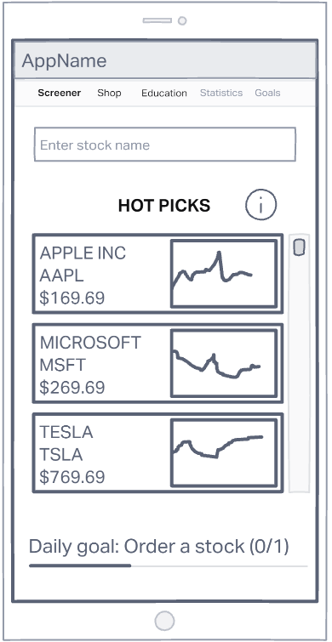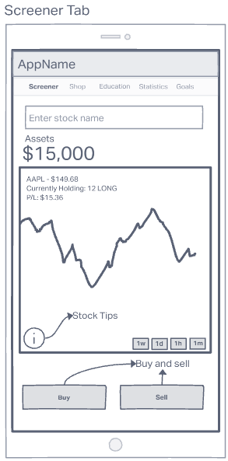

The next tab that users can navigate to is the shop tab which displays your total points and to purchase gift cards with their points earned. This encourages and incentivises users to keep trading using this app for the extra rewards especially if they are just a few hundred points short of being able to redeem a gift card. The current point-to-stock exchange rate is 10,000 points to $10 of stock.

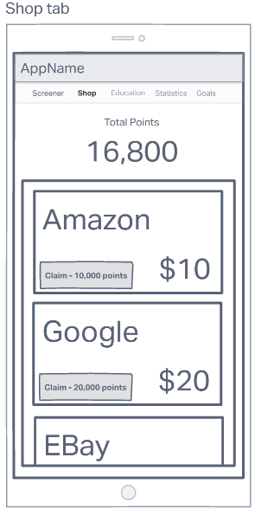

The next tab is the Education tab which is the most important tab for new investors. It contains articles from reputable sources like Forbes that users can read to learn more about investing. When a user has read through the whole article by scrolling all the way down, they will be awarded the point amount set on the side. There will be a limit of 250 points a day so they do not spam articles and just scroll to the bottom without reading anything. When they hit the limit, they can continue reading, just not gain any points for doing so. If there is a daily goal that users need to read articles, it will also appear on the bottom to encourage users to hit that goal by reading and learning.

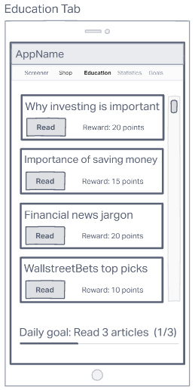

The next tab is the statistics tab where users can see how far they have progressed since day 1. This encourages them to continue on their journey and it even contains some useful information like current unrealized gains. There is another info button that explains what that information means and even provides detailed analysis on your trading profile, along with a bunch more information. There is also a win rate pie chart that shows how many trades profited and how many have lost.

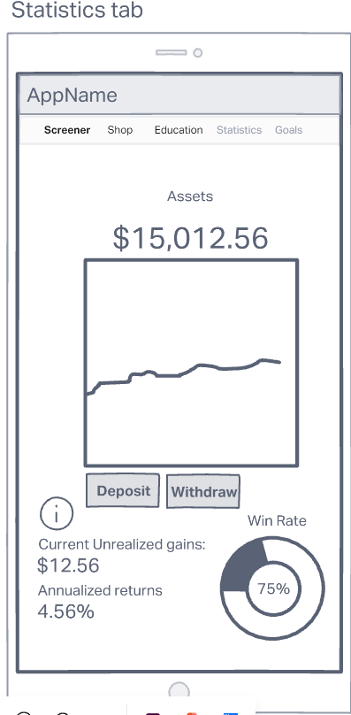

The last tab is the goals tab which simply shows their daily and weekly goals. There will be 2 goals for each category, and the weekly goal will be a larger scale version of the daily goals. Once the goals are achieved, the respective goal will be striked off and the user will be rewarded points. This lets people know how close they are to gaining those sweet rewards and might put in a few extra minutes just to read up on that last article for the points.

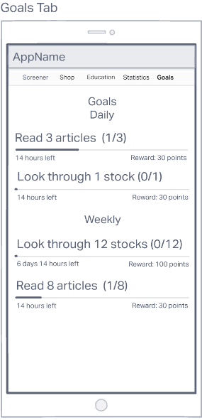

Task list